Kevin Allen

Ken Wang

Matthew Troutman

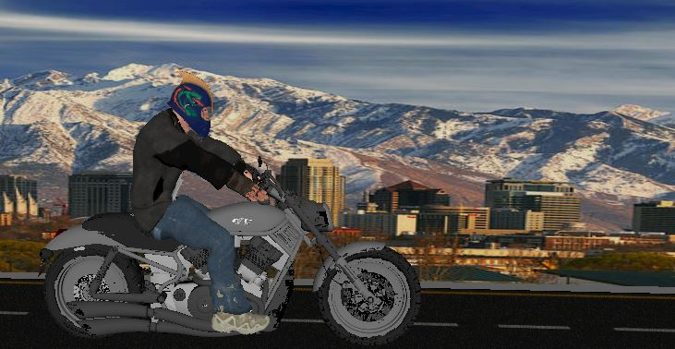

Safety First, is a game to teach you how to ride a motorcycle and how to be safe on a motorcycle. This will also give drivers who don’t have a bike to look out for them. You learn how to shift, turn, and even how to change lanes. This way you can get home safely. You will have to look out for other cars which driving on the road also.

The goals by the end of the semester being able to have a way to use this to train for your motorcycle endorsement. Have a traffic game to practice your skills you learn in the training for your endorsement to get home safely. We also want to try (if we have time) to get a dirt track to do some off road safety.